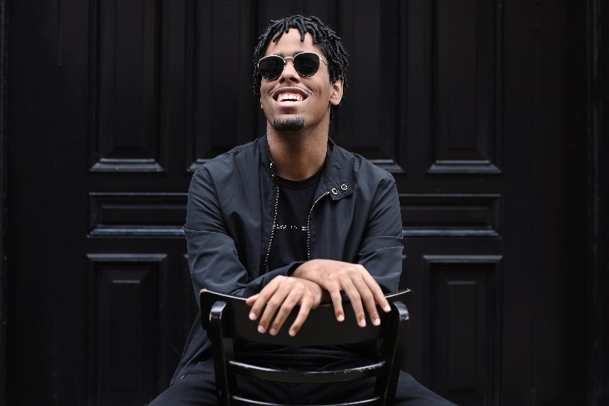

Matthew Whitaker Bio
Matthew's musical journey began at age three with a keyboard gift from his grandfather. He's now an artist, captivating audiences globally and appearing on notable T.V. shows like Showtime at the Apollo, the Today Show, Ellen, and a feature on 60 Minutes.
Matthew is a versatile artist, starring, producing, and scoring the All-Arts Emmy-nominated documentary "About Tomorrow" and scoring the film "Starkeisha," which is currently streaming on Hulu. He also appeared in and contributed music to the Emmy-winning Apple T.V. commercial "The Greatest." Matthew made his musical director debut for the award winning "Billy Strayhorn: Something to Live For." A musical on the life of pianist and composer Billy Strayhorn, which premiered in Pittsburgh, PA, in the fall of 2023. He’s had guest soloist appearances with orchestras and symphonies including Aspen Chamber Symphony, under the baton of guest conductor, Marin Alsop, and the National Arts Centre Orchestra in Ottawa, CN, Alexander Shelley, conductor. He also composed a song for the 82-piece Bulgarian Symphony Orchestra, in Sofia, Bulgaria, which was included in the aforementioned All-Arts documentary, “About Tomorrow.” Matthew created the musical score ‘Finding Free’ for the Alvin Ailey Dance Company’s 2024-2025 season, choreographed by Hope Boykin it premiered in New York City and toured across the U.S.
Matthew believes that music connects us all and that every child should have access to music education. Beyond music, Matthew advocates for persons with disabilities, consulting with companies to improve accessibility features.
He is a three-time ASCAP Foundation Herb Alpert Young Jazz Composers Award winner, with three studio albums as a leader; "Outta The Box," "Now Hear This," and "Connections." His fourth recording, "On Their Shoulders: An Organ Tribute," (2024) an homage to some of Matthew's heroes on the instrument, is nominated for Outstanding Jazz Album by the 2025 NAACP Image Awards. Matthew has collaborated with industry greats like pianist, multiple Grammy-award winning composer, vocalist, and band leader Jon Batiste; Grammy-award winning bassist Christian McBride; bassist, composer, and producer Derrick Hodge; pianist, composer; musical director Ray Chew; and NEA Jazz Master, violinist Regina Carter; and Anderson Paak during the 2024 Paralympics Handover Ceremony.

